Artificial Intelligence for Simulation

Tank War Report

Attendance

Introduction

Our group consists of six individuals, these are: Daniel, Nikesh, Theo, Phillip, Sam and Steve. We have been given a task based around a program provided where there are two tanks, both with a ‘DumbTank’ class assigned and we need to implement a new ‘SmartTank’ class using techniques we have learnt throughout the module. We are going to use a finite state machine to allow our tank to perform multiple different actions when required, allowing it to choose the best strategy available at the time. We hope to create several SmartTanks all with unique characteristics with each set of characteristics being tested to check how effective they are against other tanks.

Finite State Machine

Within our Finite State Machine, we plan on having multiple states which will change depending on when certain variables are met within the program which can include but is not limited to the health percentage of the tank or whether a target has been found.

Here are some of the notes we have made:

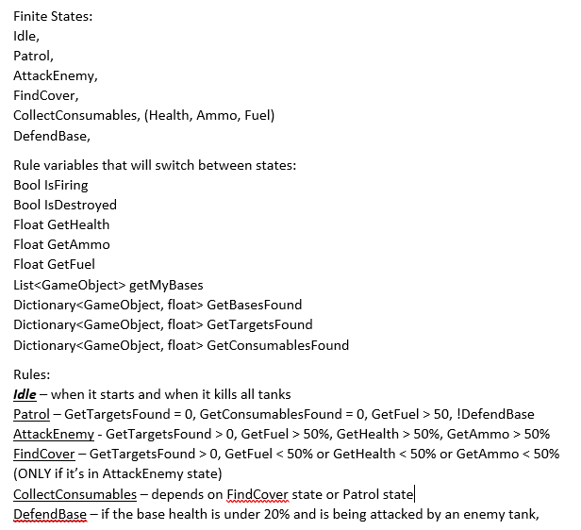

Fig [1]

Alternate AI States

We plan on adding alternative AI states with different rule sets in the finite state machine as this will allow us to test multiple different strategies out whilst seeing which one is the most effective, some of these ideas are:

Kamikaze Tank: Will continue to attack even if its resource levels are low. The AttackEnemy state rules (as seen in Fig [1]) would be changed so that GetFuel, GetHealth and GetAmmo are irrelevant and it just continues to attack no matter how low its resources are.

Resourceful Tank: Will always prioritise keeping consumables full. The AttackEnemy and FindCover state rules (as seen in Fig [1] ) would be changed so that the GetFuel, GetHealth and GetAmmo values would be set at a threshold of 120% whilst it is below this threshold it will Patrol until it finds consumables.

Defensive Tank: Will always be in cover, attacking when it is safe too, defending another tank (if multiple tanks on field). The FindCover state rule (seen in Fig [1]) would be the highest rule for this tank next being AttackEnemy (seen in Fig [1]) these rules would be switched depending on several dependences (in enemies’ line of sight, behind an object, if we have enough ammo and what our health is on. GetFuel, GetHealth and GetAmmo values would be at a threshold of 30% while DefendBase would be 70% so it would defend the base as it is created to defend/be defensive.